**CHAPTER 1**

**INTRODUCTION**

* 1. Project Context

**Title: Tarpaulin Ordering System**

The Tarpaulin Ordering System is a newly developed technological solution that aims to streamline the process of ordering customized tarpaulins. Traditionally, customers have had to manually place their orders, which often led to errors and long wait times. This system has been designed to eliminate these problems by allowing customers to order their desired tarpaulin at the touch of a button, at any time and from any location.

The system has been built with a user-friendly interface that makes it easy for customers to select the size, color, material, and design of their tarpaulin. In addition, customers have the option to upload their own artwork to make their tarpaulin truly unique. The aim is to provide a hassle-free experience for customers, allowing them to save time and effort while ordering their tarpaulins.

Overall, the Tarpaulin Ordering System represents a significant step forward in the area of tarpaulin production and customization. By automating the ordering process and providing customers with greater control over the design of their tarpaulins, this system promises to enhance the overall customer experience and set new standards for the industry.

1.2 Purpose and Description

An application that enables customers to order goods or services online is known as an online ordering system . A capstone project might involve creating an online ordering system for a particular company or sector, like a restaurant, grocery store, or clothing retailer.

An online ordering system should, in general, be simple to use, safe to use, and dependable, giving customers a seamless online shopping experience and allowing businesses to streamline their operations and boost their sales

1.3 Objectives

This Capstone Project aimed to meet the following objectives:

* To create an online platform that allows customers to easily order custom-made tarpaulins.
* To provide a user-friendly interface that allows customers to browse products, select items, and place orders with ease.
* To offer a secure payment gateway that accepts only one payment method
* To provide a system that allows customers to track the status of their orders, including order confirmation, payment confirmation, and delivery status.
* To create an admin panel that allows administrators to manage the product catalog, user accounts, and orders.
* To develop a report generation feature that shows the order history, sales, and revenue to help administrators make data-driven decisions.
* To ensure system availability as much as possible and to minimize downtime due to maintenance or technical issues.
* To establish a customer support system that can promptly respond to customer inquiries or issues through email or chat support.

Scope and Limitation

A Tarpaulin Ordering System is an online platform that allows users to easily order custom-made tarpaulins. The system has the potential to provide a range of benefits for customers, including increased convenience, flexibility, and efficiency.

The following are some of the potential features of our Tarpaulin Ordering System:

* **User registration**: Allow users to create an account on your platform so that they can place orders and manage their profile.
* **Product Catalog**: Create a comprehensive list of tarpaulin products that customers can choose from. Each product should have a description, image, and price.
* **Order placemen**t: Allow users to place orders by selecting the product, providing the quantity, and specifying the delivery date and address.
* **Payment processing**: Provide a secure payment gateway that accepts one payment method which is Gcash.
* **Order tracking**: Allow users to track the status of their orders, including order confirmation, payment confirmation, and delivery status.
* **Customer support**: Provide a way for customers to get help with any issues they may have, such as order status inquiries, product information, and payment processing.
* **Admin Panel**: Allow admins to manage the product catalog, user accounts, and orders. Also, provide a report generation feature that shows the order history, sales, and revenue.

Limitations:

However, there are some limitations to consider when developing a Tarpaulin Ordering System, including:

* **TShipping coverage**: The system can only cater to a specific geographic area, and shipping outside that area is not possible.
* **Payment methods**: Due to technical limitations, the system may not support all available payment methods.
* **Inventory management**: The system cannot provide real-time inventory updates, which may lead to out-of-stock items.
* **Customization**: The system may not offer customization options for the products, such as size, material, or design.

Definition of Terms

The proponents provided the conceptual and operational definition of the following terms for better understanding of the proposed capstone project.

* **Add Attachment**: Refers to the ability of customers to upload their own layout or image file to be printed on the tarpaulin.
* **Checkout**: The process of reviewing the order details and making payment for the selected tarpaulin products.
* **Order tracking**: The feature that enables customers to monitor the status of their orders, including updates on production and shipping.
* **Payment gateway**: The online service that securely processes payment transactions made through the Tarpaulin Ordering System.
* **Product catalog**: The list of available tarpaulin products with their corresponding descriptions, images, and prices.
* **Shopping cart**: The feature that allows customers to temporarily store selected tarpaulin products before proceeding to the checkout process.
* **User account:** The personal account created by customers to access the Tarpaulin Ordering System, which may include personal and payment information.
* **Delivery address**: The physical address where the tarpaulin products will be delivered.
* **Quantity**: The number of tarpaulin products that a customer intends to purchase.

**CHAPTER 2**

**REVIEW OF RELATED LITERATURE AND SYSTEMS**

Provide an introductory paragraph that briefly describes the contents of the sections and how they are organized.

Example: This chapter presents the related literature and related systems to provide better understanding of the proposed capstone project.

* 1. Related Literature

Tarpaulin Ordering Systems have become increasingly popular in the printing industry, as they can help streamline the ordering process and improve customer satisfaction

According to R., "An Analysis of Tarpaulin Ordering Systems for Small Printing Shops" De Guzman, R. De Guzman, T. De Guzman, and J. B. Domingo, E. (2018). The effectiveness of tarpaulin ordering systems for small printing shops is examined in this paper. The study looks into how tarpaulin ordering systems affect small printing shops' productivity, client satisfaction, and financial health.

The importance of tarpaulin ordering systems is covered in the opening section of the paper, along with the difficulties small printing shops face in implementing such systems. The study's findings are then presented by the authors. It was based on surveys and interviews with small printing businesses that have ordered tarpaulin systems. According to the study, tarpaulin ordering systems can increase productivity and boost customer satisfaction, and the success of small print shops. The need for staff training, upfront investment costs, and compatibility with existing systems are just a few of the difficulties the authors noted in implementing tarpaulin ordering systems.

This paper highlights the advantages and potential difficulties of tarpaulin ordering systems for small printing shops that are thinking about implementing them.

This paper presents a case study comparing various tarpaulin ordering systems for printing businesses. The study evaluates the features, cost, and usability of the various systems, and offers recommendations for printing businesses that are thinking about implementing a tarpaulin ordering system. The authors present the findings of their case study, which involved comparing three different tarpaulin ordering systems in terms of their features, cost, and ease of use, before they discuss the significance of tarpaulin ordering systems in the printing industry and the advantages they can offer to printing businesses, such as improved efficiency and customer satisfaction.

According to the study, all three tarpaulin ordering methods were successful in streamlining the procedure and minimizing errors. However, the systems varied in price and usability, with some requiring more customization and training than others. The authors offer suggestions for printing companies that are thinking about implementing a tarpaulin ordering system based on their findings, including weighing the cost and usability of various systems and ensuring that staff are properly trained in using the system.

Overall, this paper offers insightful information about the various tarpaulin ordering methods accessible to printing companies, and it can assist companies in deciding which method is best suited to their requirements.

According to Durieux, P., Trinquart, L., Colombet, I., Nies, J., & Walton, R. (2009). The design and implementation of a computerized ordering system for a hospital emergency room are covered in this study. The study employs a case study methodology to examine the system and how it affects the effectiveness and standard of care offered in the emergency room. Data was gathered through staff member interviews and observations both before and after the system was put into place.

The study found that the emergency department benefited from the computerized ordering system in a number of ways, including increased order processing efficiency, improved physician-patient communication, and decreased medication administration errors. However, the study also noted a number of difficulties with the system's implementation, including the requirement for staff training, adjustments to workflow, and resistance to change. According to the study's findings, installing a computerized ordering system in a hospital emergency room can significantly enhance patient care, but careful planning and management are required to make sure the installation goes smoothly.

According to Herman, G. T., Herman, G. E., & Barrett, M. E. (2012). The design and implementation of an electronic ordering system for radiologic exams in an outpatient setting are discussed in this study. The system and its impact on the effectiveness and caliber of care offered in the radiology department are examined using a case study methodology in the study. Data was gathered through staff member interviews and observations both before and after the system was put into place.

According to the study, the radiology department benefited from the electronic ordering system in a number of ways, including increased order processing efficiency, improved physician-patient communication, and decreased ordering and scheduling errors. The study also identified a number of obstacles to the system's implementation, such as the need for staff training and adjustments to workflow. The study's findings suggest that putting in place an electronic ordering system for radiologic exams in an outpatient setting can significantly boost both operational effectiveness and patient care, but careful planning and management are essential to make sure the implementation is successful.

According to Lesar, T. S., Briceland, L., Stein, D. S., & West, P. (2010). This research looks at how an automated pharmacy system affects medication ordering mistakes in a pediatric hospital. The study compares medication error rates before and after the implementation of the system using a quasi-experimental design. Through the review of charts and electronic records, data was gathered. The study discovered a significant decline in medication ordering errors was associated with the adoption of the automated pharmacy system.

In particular, the error rate for medication orders dropped from 11.3 errors per 1,000 orders prior to the system's implementation to 5.5 errors per 1,000 orders afterward. The study also discovered that the automated pharmacy system reduced the time needed for medication administration and increased the effectiveness of processing medication orders. According to the study's findings, a pediatric hospital's automated pharmacy system can significantly lower medication ordering mistakes, enhancing patient safety and healthcare quality.

* 1. Related Systems

Square POS is a point-of-sale system that operates in the cloud and provides a number of features for small businesses, such as payment processing, inventory control, and customer relationship management. The main features, advantages, and drawbacks of Square POS are covered in this paper's overview. To give a comprehensive understanding of the platform's capabilities and potential for small businesses, the study draws on previously conducted research and analysis of the platform. The ease of use, affordability, and compatibility of Square POS with a wide range of other devices and services are highlighted in the paper. The system does have some drawbacks, such as the limited support for multiple locations and the requirement for a reliable internet connection, which are noted in the paper. According to the study's findings, Square POS can be a useful tool for small businesses trying to enhance their operations, but careful thought must be given to whether it will actually meet the unique needs of each business.

An on-demand grocery delivery service called Instacart links customers with personal shoppers who carry out orders and deliver them to customers' homes. The Instacart system and its effects on the grocery delivery sector are examined in this study. The study analyzes the key components of the Instacart platform, including its user interface, delivery procedure, and customer service, using a case study methodology. The study assesses the system's benefits and drawbacks for customers, retailers, and wholesalers. According to the research, Instacart has changed the way that groceries are delivered by providing a more convenient and tailored service. The study highlights the advantages of the Instacart system, such as better customer satisfaction, easier access to groceries, and higher sales for retailers. The study does point out some system flaws, though, like delivery delays and higher customer costs. According to the study's findings, Instacart has the potential to completely change the grocery delivery business, but to keep up with the competition, it will need to keep innovating and making improvements.

Amazon Go is a cutting-edge brick-and-mortar retail system that eliminates the checkout process through the use of cutting-edge technologies. The Amazon Go system and its effects on the retail sector are examined in this study. The study analyzes the key components of the Amazon Go platform, including its use of computer vision, sensor fusion, and machine learning, using a case study methodology. The study compares and contrasts the benefits and drawbacks of the Amazon Go system for retailers and customers. The results suggest that by providing a quicker, more practical, and more customized shopping experience, Amazon Go has disrupted the conventional retail model. The study highlights the advantages of the Amazon Go system, such as improved inventory control, lower overhead costs for retailers, and higher customer satisfaction. The study does, however, also point out some of the system's drawbacks, including its expensive implementation costs and potential privacy issues. The study comes to the conclusion that Amazon Go has the potential to revolutionize the retail sector, but that some of its problems and constraints will require ongoing innovation and improvements.

* 1. Synthesis

A review of the literature gathered from various studies revealed that technologies are rapidly evolving. Being smart and open-minded in various ways to outperform competitors in the business industry, which leads to the development of systems that will aid in the easy ordering and tracking of orders. Some strategies were implemented to meet the client's fulfillment, such as using a online ordering system and achieving a more reliable and efficient means of monitoring orders.The use of technology in streamlining business processes has become increasingly popular, and one such process that could benefit from technology is the tarpaulin ordering system.

The proposed capstone project is most closedly Instacart System. Both the tarpaulin ordering system and Instacart are examples of online ordering systems that allow customers to purchase products or services from the comfort of their own homes.However, there are some key differences between the two systems.

The tarpaulin ordering system is designed for businesses and individuals who need to order custom-sized tarpaulins for various applications such as construction, events management, and advertising. The system typically involves the customer selecting the tarpaulin's size, material, and other specifications, then submitting their order online. The tarpaulin will then be manufactured and delivered to the customer.

On the other hand, Instacart is a grocery delivery service that allows customers to order groceries online from local stores and have them delivered to their doorstep. Customers can select the groceries they want, choose a delivery time, and pay online. Instacart then sends a personal shopper to the store to pick up the items and deliver them to the customer.

While both systems have the same goal of providing a more convenient and streamlined way for customers to order products or services, the tarpaulin ordering system is more specialized and tailored to a specific industry, whereas Instacart is a more general-purpose system that can be used by anyone looking for grocery delivery services.

**CHAPTER 3**

**TECHNICAL BACKGROUND**

This chapter provides an overview of the system's general processes, as depicted in the IPO (Input, Process, and Output). The researchers also listed the applications and software that were used in the system's development in this chapter.

The researchers used Firebase Authentication,is a service provided by Firebase, a mobile and web application development platform, that allows developers to easily authenticate users to their applications. It provides secure user authentication and authorization for a variety of platforms, including iOS, Android, and web applications, using email and password, phone number, social media, and other authentication methods. Firebase Authentication also integrates with other Firebase services, such as Cloud Firestore, Cloud Storage, and Cloud Functions, to provide a complete solution for building scalable and secure applications. With Firebase Authentication, developers can focus on building great user experiences, while leaving the complexity of user authentication and security to the Firebase platform.

The researchers also used React.JS, It commonly referred to as React, is an open-source, front-end JavaScript library used for building user interfaces (UIs) or UI components. Developed by Facebook, React allows developers to create reusable UI components and manage their state in a way that makes it easy to build large, complex applications. React makes use of a "virtual DOM" to efficiently update the user interface when data changes, and it emphasizes a declarative programming style that allows developers to describe what the UI should look like in response to changes in data, rather than specifying how to change the UI. React can be used on its own, or in combination with other libraries and frameworks to build complete web applications.

The researchers of the study are to apply the use of  System Approach Theory, consisting of the IPO (Input, Process, and Output) chart model, to make it less complicated and quicker to comprehend the study's mean qualities. The chart model reduced the uncertainty in the development of the proposed system which is illustrated in Figure 1.

#### Figure 1 IPO Diagram

The Tarpaulin Ordering System is a web-based platform that enables customers to easily place orders for tarpaulin products. Customers can register an account and log in securely using their email and password, as well as reset their password if needed through an email-based process.

Once logged in, customers can create their tarpaulin design by selecting the desired size and material. The system then validates the customer's details and specifications to calculate the total cost of the order. Customers can then process their payment securely through the platform, and the order details are sent to the production team for fulfillment.

To ensure that the production team receives accurate and complete details of the customer's order, the system verifies the information provided by the customer. Additionally, customers can upload a file to the form to provide additional information to the admin.

**CHAPTER 4**

**METHODOLOGY  
  
FLOW CHART**

**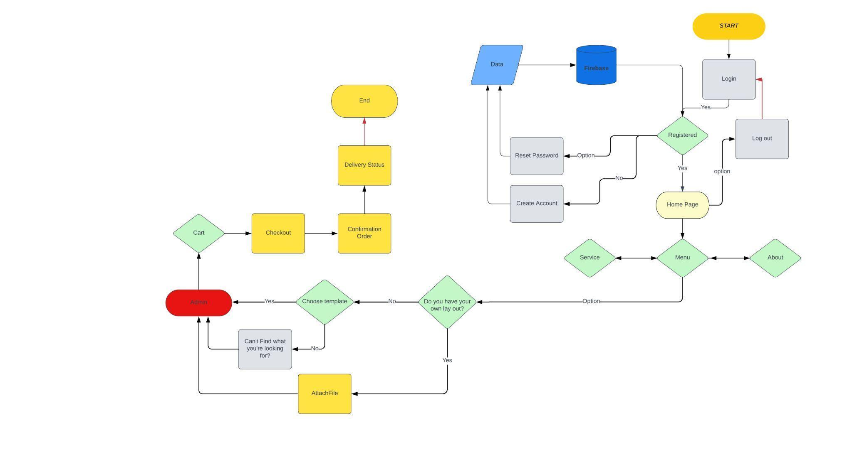  
  
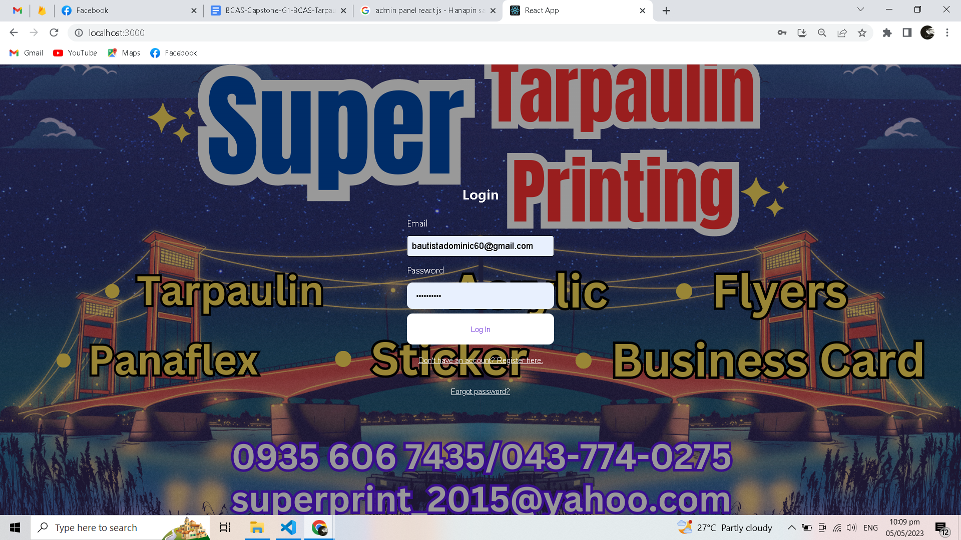  
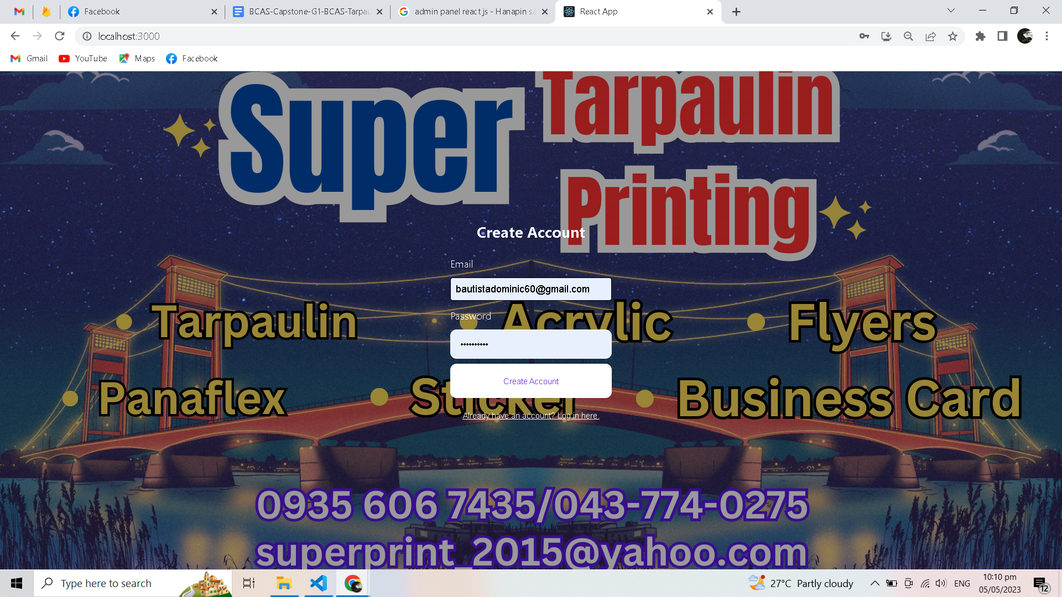**

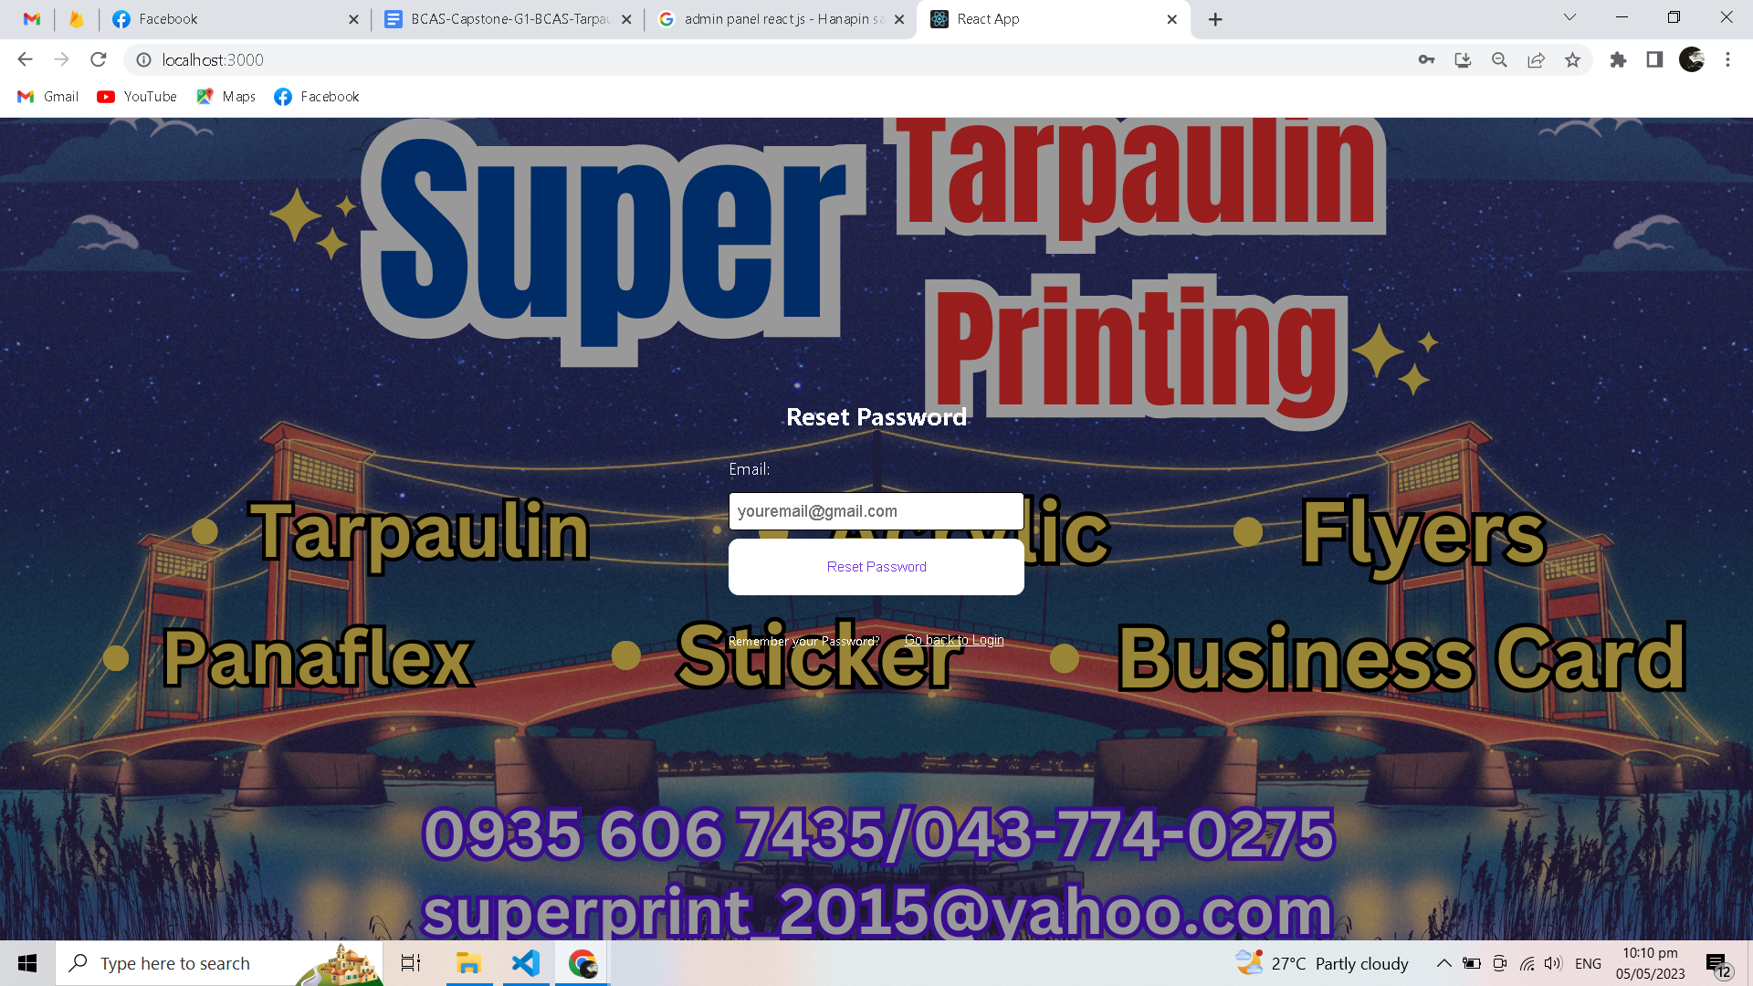  
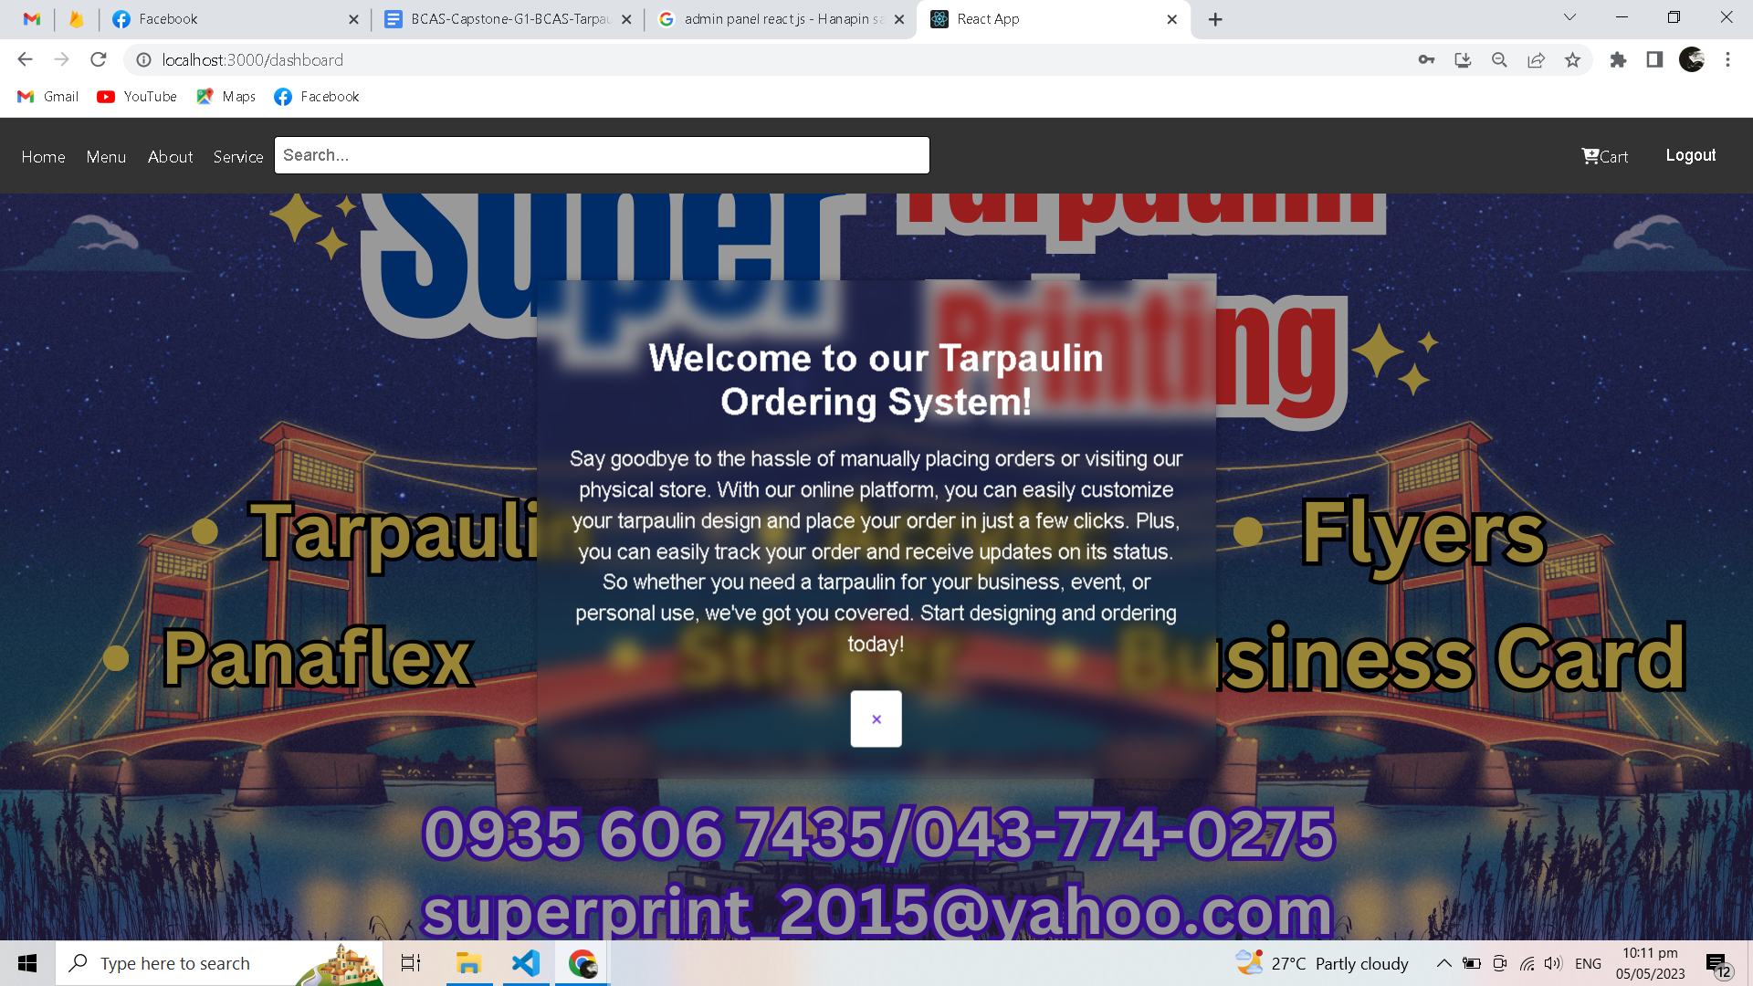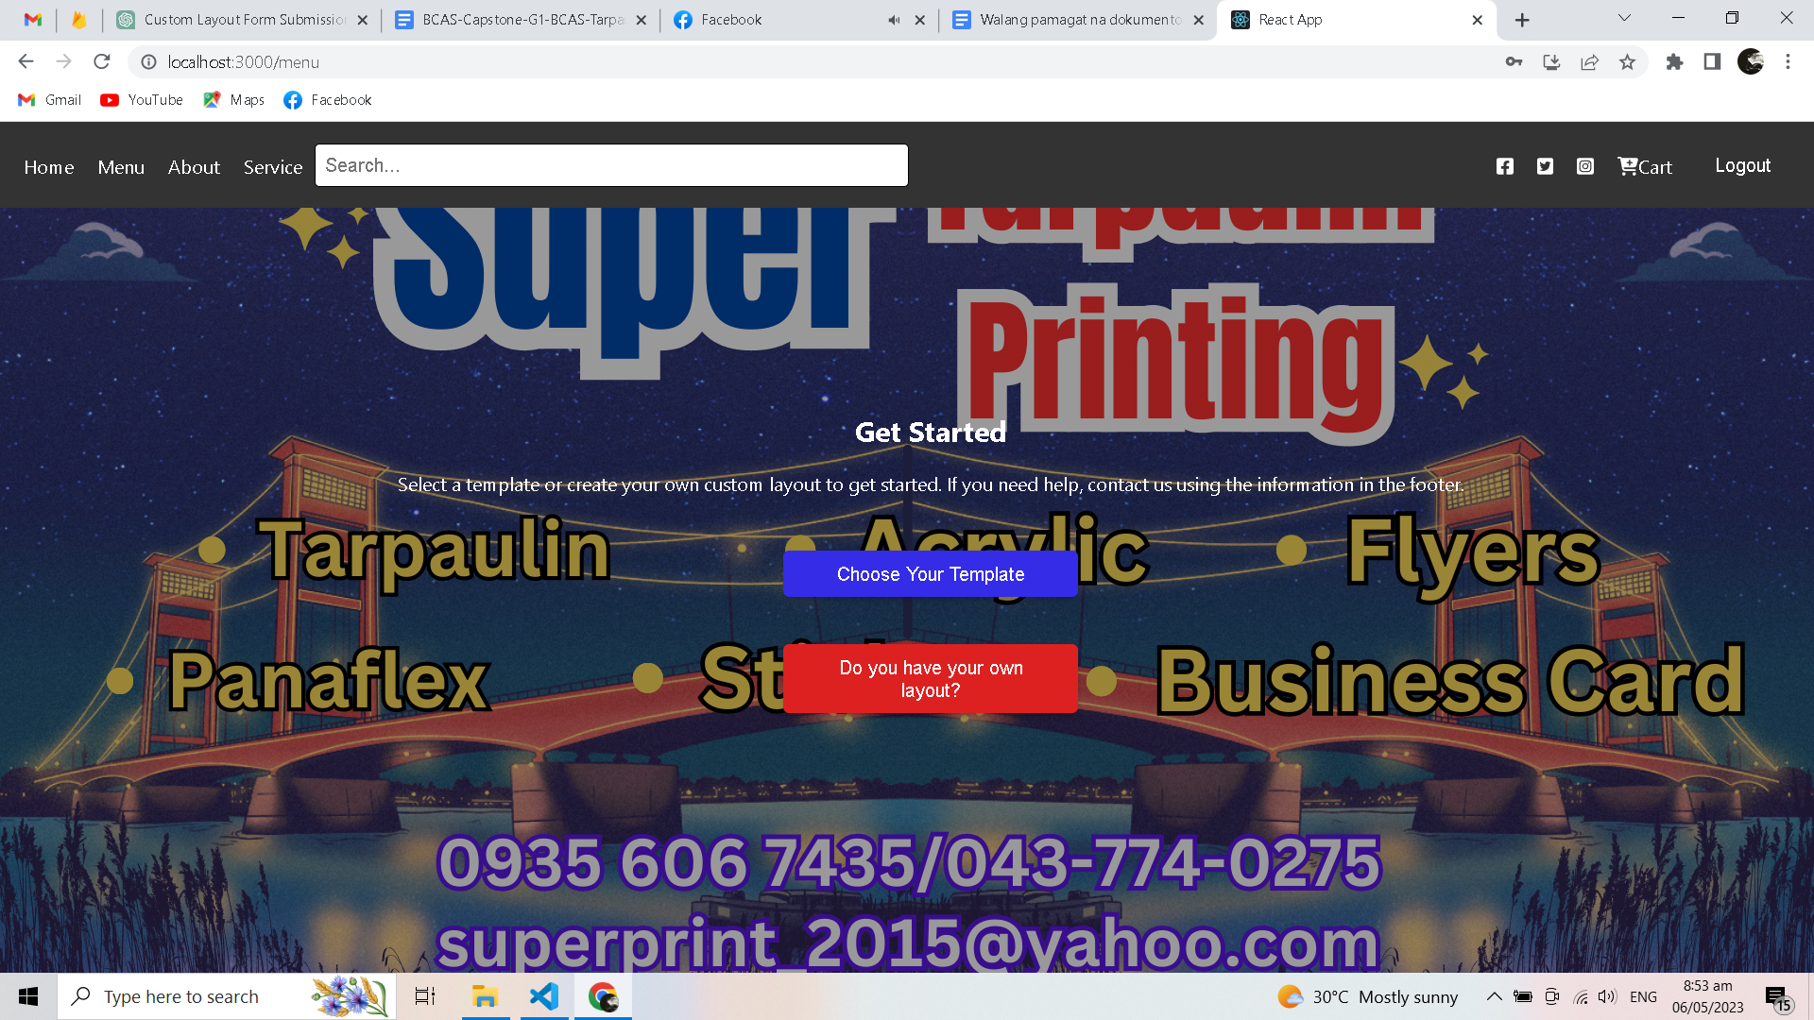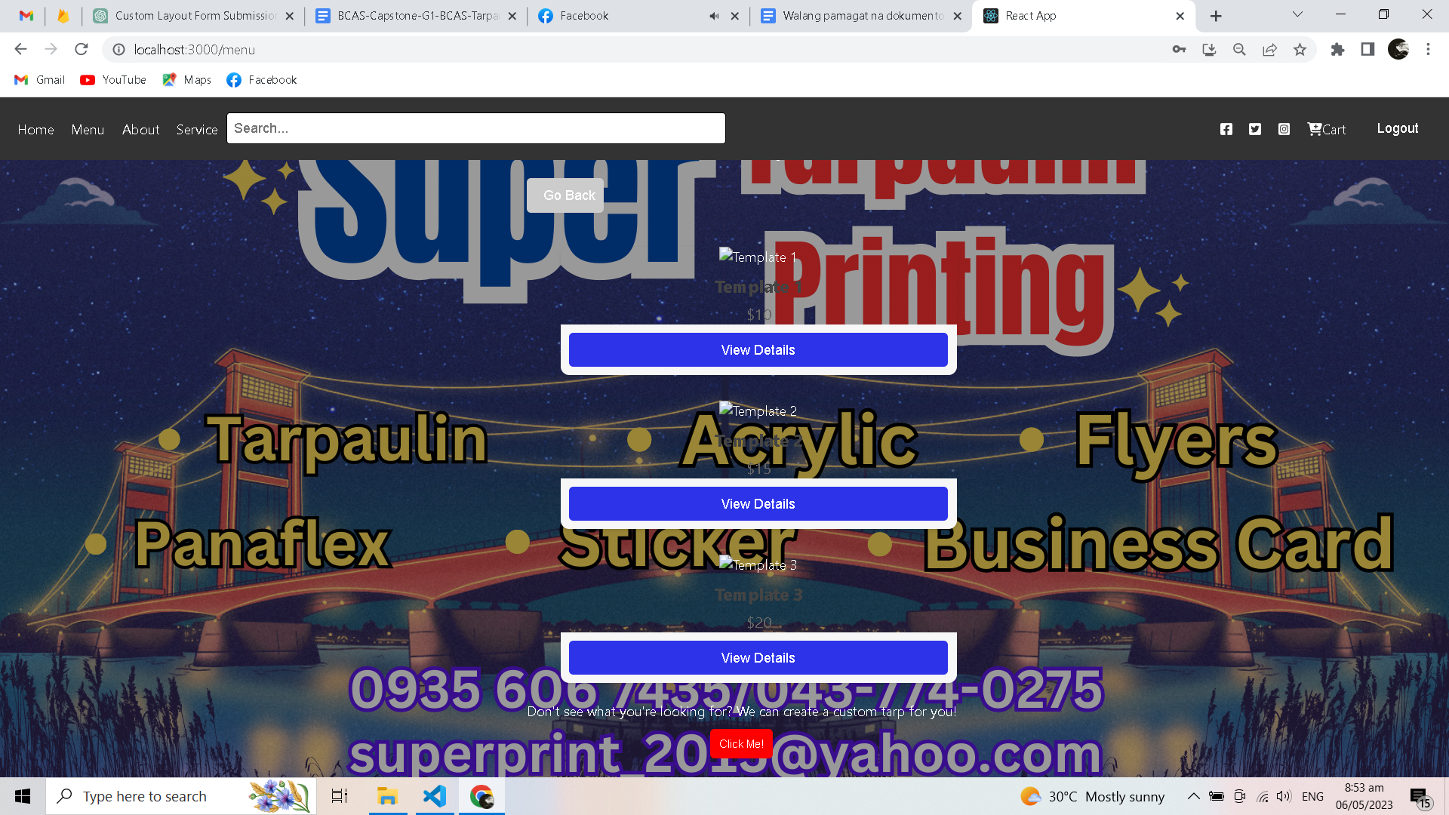  
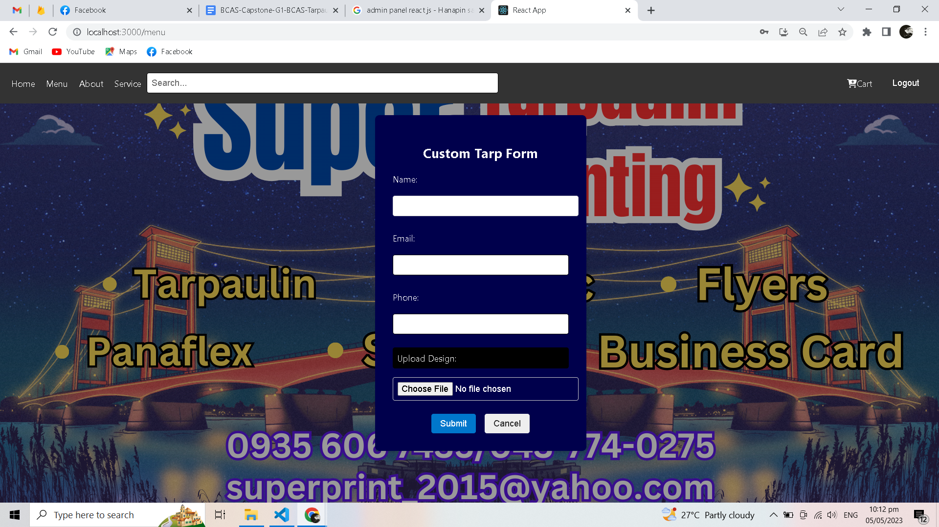  
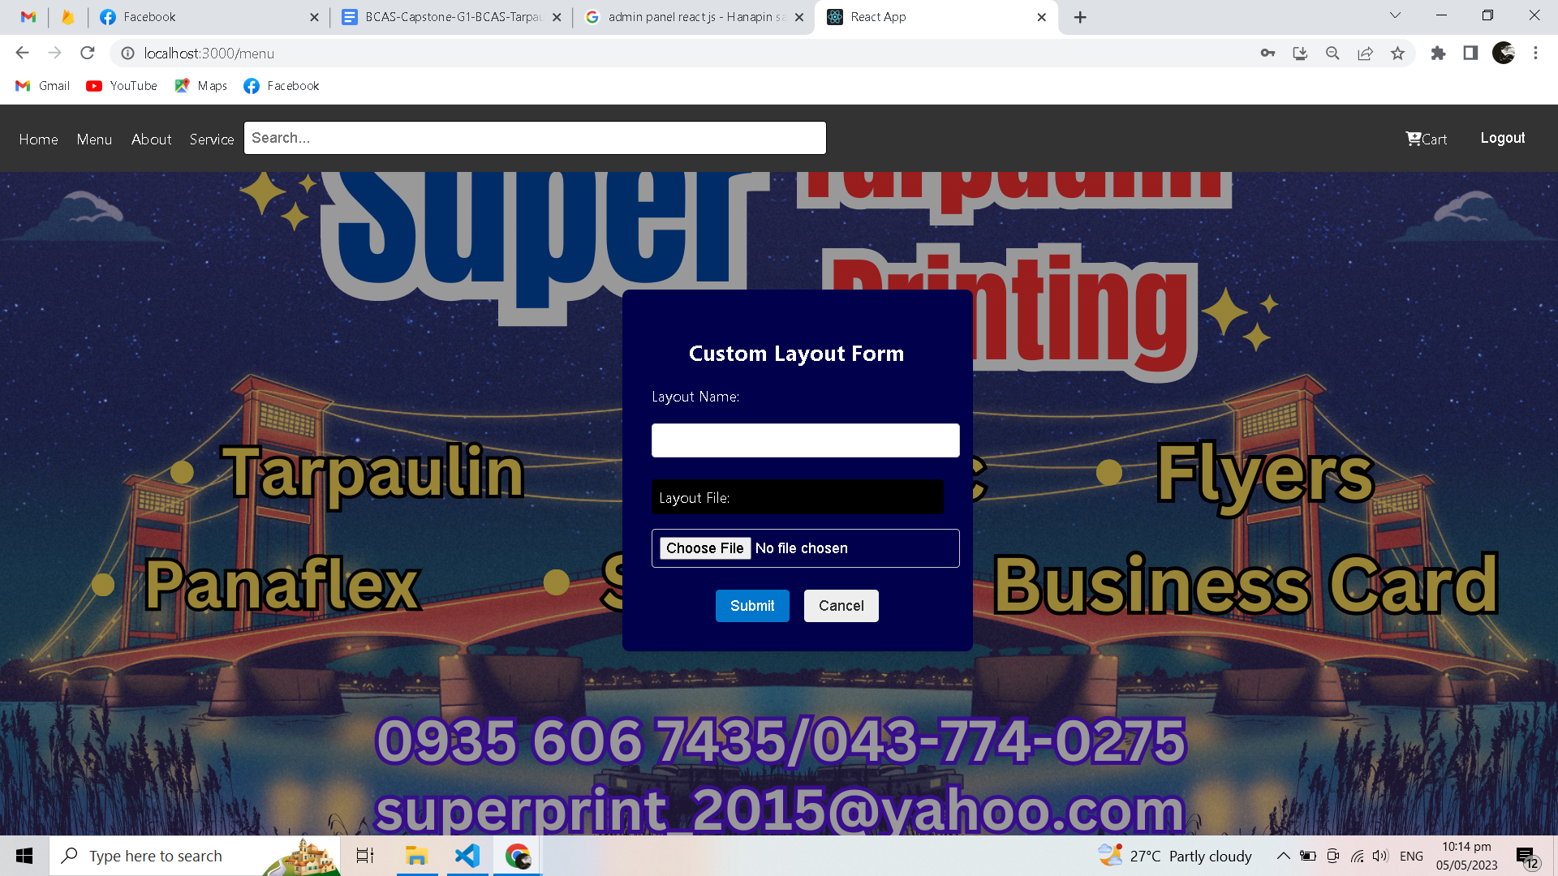  
  
  
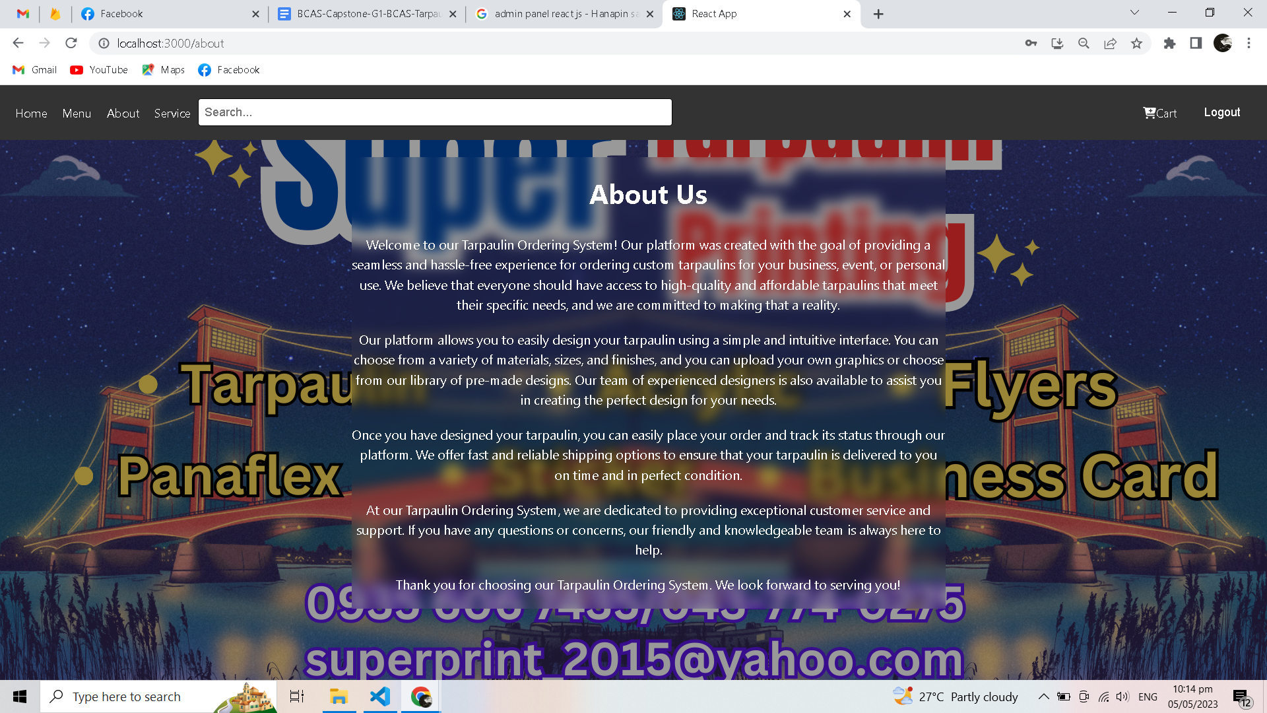  
  
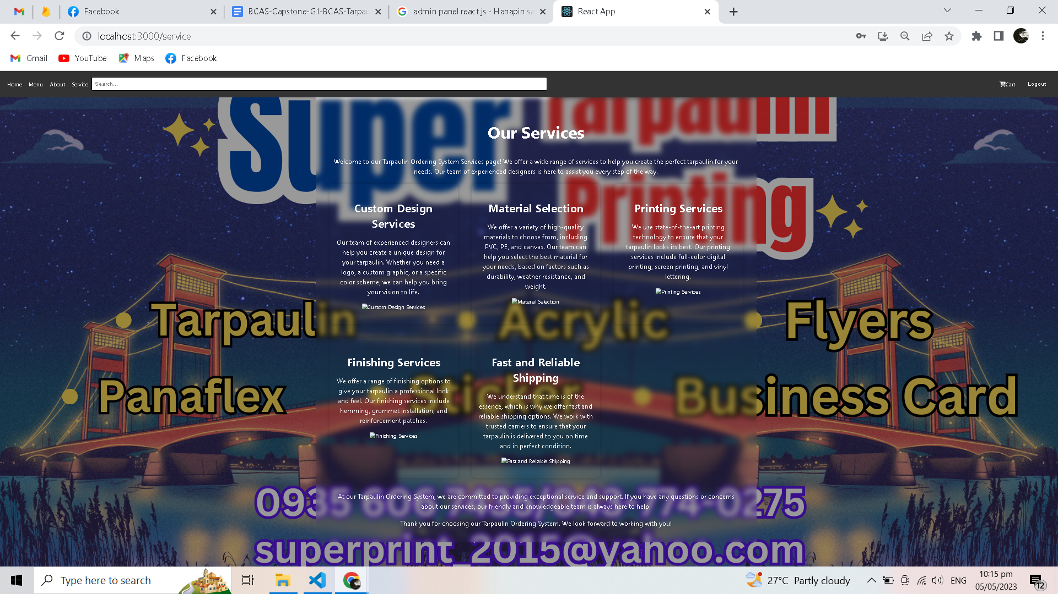  
  
  
This chapter presents the requirements analysis, requirements documentation, system design, user acceptance test and implementation plan.

4.1 Requirements Analysis

**Requirements analysis**, also known as Requirement Engineering, is the process of defining user expectations for a new software being built or modified. In software engineering, it is sometimes referred to loosely by names such as requirements gathering or requirements capturing. Requirements analysis encompasses those tasks that go into determining the needs or conditions to meet for a new or altered product or project, taking account of the possibly conflicting requirements of the various stakeholders, analyzing, documenting, validating and managing software or system requirements (Requirements Analysis Techniques, 2018).

**Example Requirements Analysis**

In the development of a system, requirements analysis is very essential. These requirements should be presented to the client so that problems regarding the implementation may be prevented. To gather preliminary data regarding the proposed capstone project, the proponents secured endorsement letter from the college assistant office to be able to set an appointment date for an interview with the target client of the proposed system. During the interview, the proponents noted all the specific requirements of the client. These include: **enumerate on this part the specific client requirements. Include detailed discussion of (a)customer's needs, (b)system for feasibility, (c)economic and technical analysis, and (d)schedule and constraints.** You can better present these items when discussed one by one in separate paragraphs that are labelled. For example,

1. **Customer’s Needs**

Discuss in this section the setting of the proposed project. The setting includes the profile of the company for whom the proposed project is intended for. Added to this section is the discussion of the customer needs relative to the proposed capstone project.

1. **System Feasibility**

Provide a discussion of how possible it is to develop the proposed system.

1. **Economic and Technical Analysis**

Provide a discussion of how the proposed system will lessen expenses, speed up processes and provide more advantages.

1. **Schedule and Constraints**

Discuss the duration of the project development from beginning until its deployment. You may use Gantt Chart for this purpose. Emphasize the boundaries and the limitations of the proposed system.

4.2 Requirements Documentation

A **requirements document** explains why a product is needed, puts the product in context, and describes what the finished product will be like. A large part of the requirements document is the formal list of requirements (Writing a Requirements Document, 2018).

1. **Introduction**

Its purpose is to provide a brief overview of the function of the proposed system and the reasons for its development, its scope, and references to the development context (e.g., reference to the problem statement written by the client, references to existing systems, feasibility studies). The introduction also includes the objectives and success criteria of the project.

1. **Current System**

This section describes the current state of affairs. If the new system will replace an existing system, this section describes the functionality and the problems of the current system. Otherwise, this section describes how the tasks supported by the new system are accomplished now (Requirements Analysis Document, 2018).

**You can include in this section the DFD of the current system.**

1. **Proposed System**

This section describes the proposed system. **You can include in this section the DFD of the proposed system.**

1. **Hardware Requirements**

Discuss the hardware requirements of your proposed system.

1. **Software Requirements**

Discuss the software requirements of your proposed system.

1. **Security Requirements**

Discuss the security requirements and features of your proposed system.

4.3 System Design

**Systems design** is the process of defining elements of a system like modules, architecture, components and their interfaces and data for a system based on the specified requirements. It is the process of defining, developing and designing systems which satisfies the specific needs and requirements of a business or organization (The Economic Times, 2018).

Provide a discussion of the enumerated items (a-c) below whichever is applicable to your proposed system.

1. **Output and User-Interface Design**

Provide a discussion of the proposed system for the following:

**Forms**

**Reports**

Diagrams and screen mock ups may also be utilized for this part.

1. **Data Design**

Provide a discussion of the proposed system for the following:

**Entity Relationship Diagram**

**Data Dictionary**

Diagrams and screen mock ups may also be utilized for this part.

1. **System Architecture**

Provide a discussion of the proposed system for the following:

**Network Model**

**Network Topology**

Diagrams and screen mock ups may also be utilized for this part.

### 4.4 User Acceptance Test

### This section presents the user acceptance test conducted by the proponents. This should narrate the proceedings conducted to test the functionality of the proposed system. A survey questionnaire must be constructed which the users will accomplish after having tested the proposed system. The table of responses must be presented in this section plus the interpretation.

1. **Participants of the User Acceptance Test**

This part describes the sampling procedure/technique for selecting your participants (e.g. systematic sampling, stratified, cluster, etc). Describe your participants in terms of some demographic variables, (e.g. sex, age, etc.) Tables and/or figures may be used to simplify the presentation of the demographic characteristics of the participants.

1. **Data Gathering Instrument**

This section describes the instrument/s and other data gathering materials you will use. Include information about the types of items and responses, the scoring procedure, evidences of reliability and validity of the instrument. If the data gathering instrument is developed by the researcher, he/she should discuss the steps on how the instrument was developed and validated. (i.e. showing evidence/s of validity and estimates of reliability).

1. **Data Gathering Procedure**

This section must describe in detail the procedure of data gathering stating the specific steps for each phase that will be taken in carrying out the research study. It may be helpful to come up with a flow chart or diagram to show the order of activities that you intend to take in conducting your study (e.g. instructions for selecting and training research assistants, how you will recruit or contact your participants, procedures for assigning participants to groups, administration of instruments including pretesting process, interviewing participants etc.) and also ethical procedures you will apply in your study (e.g. approval from the school city superintendent or principal before proceeding to data collection involving students, etc.) Overall, this part must enumerate all the activities that will be undertaken to complete your study describing each activity in detail to help future researchers who would want to replicate your study.

1. **Data Analysis**

This section discusses the procedures as to how you will score, record/encode and analyze your data to answer the research problem/s. Documents used for recording or accumulating data must be included in the appendix section. For studies that use statistical tests to analyze your data, specific descriptive statistics and/or inferential statistics that to be used must be comprehensively presented in this section.

**CHAPTER 5**

**SUMMARY OF FINDINGS, CONCLUSIONS AND RECOMMENDATIONS**

Provide an introductory paragraph to give an overview of the chapter coverage.

* 1. Summary of Findings

The summary of findings must be presented in a concise manner. Highlights of the most important findings in the study must be summarized such that the reader is given clarity so as to have a full and intended understanding of the capstone project satisfaction. This section should not appear like a copycat of the details presented in chapter 4. Note however that this section must be congruent and based with the answers to the capstone project objectives presented in chapter 4. Therefore, each objective must be given a corresponding summary of finding.

* 1. Conclusions

This section presents the conclusions with the following characteristics: brief and concise, captive of the essence of the study, direct to the point, and leading towards the recommendations.

Conclusions should be based on the results/findings of the study (i.e. given one or two or more findings for research problem number one, what conclusion/s can you derive). Conclusions are not just repeating your findings but abstractions of the summary of findings. Numerical values (e.g. mean, standard deviation, t value, F ratio, etc.) should no longer be reported in this chapter since they have already been presented in Chapter 4 (Methodology). 

See to it that your conclusions are tied to the capstone project objectives. This means that for every objective provided and summary of finding in this chapter, a corresponding conclusion must be given.

* 1. Recommendations

This section discusses the real-life implications of the study and the ways that these can be addressed. Recommendations must be written supported by evidence and grounded in the analysis and conclusions of the study.

Consider the following elements in writing the recommendations of your study: statements should offer solutions to problems identified in the study, offer alternative to current or previous approaches, and lay down the groundwork for future studies.

Note that the three sections of this chapter presented above must each begin with introductory note in one to two sentences. The specific summary of findings, conclusions and recommendations are presented in numbered format.

**REFERENCES**

This section lists the books, journal articles, publications, online articles and other materials that the researcher used in the study. The list of references must be presented in alphabetical order.

Follow the APA format presented below for each type of reference used. Because there is a wide array of types of references that a researcher can use, you need to refer to the latest APA style reference guide to ensure format compliance.

I suggest that you take time checking this link: <https://www.canberra.edu.au/about-uc/faculties/arts-design/attachments2/pdf/n-and-mrc-conference/APA-Referencing-Guide.pdf>

1. Books

**For an entire book, use the following reference formats:**

Author, A. A. (Year of Publication). *Title of work*. Location: Publisher.

Author, A. A. (Year of Publication). *Title of work*. Retrieved from http://www.xxxxxxx

Author, A. A. (Year of Publication)). *Title of work*. doi (digital object identifier):xxxxx

Editor, A. A. (Ed.). (Year of Publication). *Title of work*. Location: Publisher.

**For a chapter in a book or entry in a reference book, use the following formats:**

Author, A. A., & Author, B. B. (1995). Title of chapter or entry. In A.

Editor, B. Editor, & C. Editor (Eds.), *Title of book* (pp. xxx-xxx). Location: Publisher.

Author, A. A., & Author, B. B. (1993). Title of chapter or entry. In A. Editor & B. Editor (Eds.), Title of book (pp. xxx-xxx). Retrieved from http://www.xxxxxxx

Author, A. A., & Author, B. B. (1995). Title of chapter or entry. In A. Editor, B. Editor, & C. Editor (Eds.), Title of book (pp. xxx-xxx). doi:xxxxxxx

1. Magazines/Journals/Periodicals

Author, A. A., Author, B. B., & Author, C. C. (year). Title of article. Title of Periodical, xx, pp-pp. doi:xx,xxxxxxxxxx

Author, A.A., Author, B. B., & Author, C. C. (2004). Title of article. Title of Journal, volume, page-numbers.

Chamberlin, J., Novotney, A., Packard, E., & Price, M. (2008, May). Enhancing worker well-being: Occupational health psychologists convene to share their research on work, stress, and health. Monitor on Psychology, 39(5), 26-29.

Clay, R. (2008, June). Science vs. ideology: Psychologists fight back about the misuse of research. Monitor on Psychology, 39(6). Retrieved from http://www.apa.org/monitor/

1. Online Sources

Brody, J. E. (2007, December 11). Mental reserves keep brain agile. The New York Times. Retrieved from http://www.nytimes.com

1. Dissertations/Theses

For a doctoral dissertation or master’s thesis available from a database service, use the following reference template:

Author, A. A. (2003). Title of doctoral dissertation or master’s thesis (Doctoral dissertation or master’s thesis). Retrieved from Name of database. (Accession or Order No.)

For an unpublished dissertation or thesis, use the following template:

Author, A. A. (1978). Title of doctoral dissertation or master’s thesis (Unpublished doctoral dissertation or master’s thesis). Name of Institution, Location.

**Master’s thesis, from a commercial database**

McNeil, D. S. (2006). Meaning through narrative: A personal narrative discussing growing up with an alcoholic mother (Master’s thesis). Available from ProQuest Dissertations and Theses database. (UMI No. 1434728)

**Doctoral dissertation, from an institutional database**

Adams, R. J. (1973). Building a foundation for evaluation of instruction in higher education and continuing education (Doctoral dissertation). Retrieved from http://www.ohiolink.edu/etd/

**Doctoral dissertation, from the web**

Bruckman, A. (1997). MOOSE Crossing: Construction, community, and learning in a networked virtual world for kids (Doctoral dissertation, Massachusetts Institute of Technology). Retrieved from http://www-static.cc.gatech.edu/~asb/thesis/

**APPENDICES**

1. Letter/s

This section presents all letters used in the conduct of the study which include letter/s of request, acceptance letter, etc.

1. Data Gathering Instrument

This section appends the actual copy/ies of the data gathering instrument/s used in the study.

1. Table of Response Time
2. Certification of Grammarian
3. Relevant Source Code
4. Other Supporting Documents

This section includes all other documents or accompanying/extra materials used in the conduct of the study.

1. Profile of the Researcher/s

**PROFILE OF THE RESEARCHER/S**

Follow this format for the profile of the researcher/s.

**Full Name** XXXXXXXXXX X XXXXXXXXXXXX

**Email Address** xxxxxxx@xxxxxxx.com

**Educational Attainment**

**Baccalaureate Degree** Baccalaureate Degree Course

Name of School

Address

Inclusive years

**Senior High School** Track and Strand

Name of School

Address

Inclusive years

**Junior High School** Name of School

Address

Inclusive years

**Grade School** Degree Course

Name of School

Address

Inclusive years

**Work Experiences (chronological from present)**

Name of Company

Address

Position

Inclusive years/dates

**Academic and Non-Academic Achievements**

Title/Description of the Achievement XXXXXXXXXXX

School Year & Semester(if applicable) XXXXXXXXXXX

**Study Grants/Scholarship/s Received**

Title/Description of Scholarship XXXXXXXXXXX

School Year & Semester(if applicable) XXXXXXXXXXX

**Professional/Civic Affiliations**

Name of Organization XXXXXXXXXXXX

Position XXXXXXXXXXXX

Inclusive years/dates XXXXXXXXXXXXX

**Dear BSIT student,**

**Please note that this page is not part of the BSIT Capstone Project Documentation Template. These are the sources that were used to create this template.**

**References**

# Villanueva, J. (2017, January 31). *Chapter 1(Research Description) Capstone Project Guidelines and Sample.* Retrieved December 19, 2018, from https://itsourcecode.com/2017/01/chapter-1-research-description-capstone/)

# Villanueva, J. (2017, January 31). *Chapter 1 Introduction.* Retrieved December 19, 2018, from https://itsourcecode.com/wp-content/uploads/2017/01/CHAPTER-01.pdf

# Ticatic, J., et al., (2013). *Dr. E. G. Information and Billing System.* Unpublished Capstone Project. Batangas College of Arts and Sciences, Inc., Lipa City

# Requirements Analysis Techniques. (2018, December 19). Retrieved from https://www.visual-paradigm.com/guide/requirements-gathering/requirement-analysis-techniques/

# Writing a Requirements Document. (2018, December 19). Retrieved from http://www.cdl.edu/uploads/Qd/S6/QdS615B1DcnwRZlnSuTDnQ/writing-requirements.pdf

# Requirements Analysis Document. (2018, December 19). Retrieved from http://www.cs.fsu.edu/~lacher/courses/COP3331/rad.html

# The Economic Times. (2018, December 19). Retrieved from https://economictimes.indiatimes.com/definition/systems-design

# CHED Memorandum Order No. 25, s2015. Commission on Higher Education. (2018, December 19). Retrieved from https://ched.gov.ph/wp-content/uploads/2017/10/CMO-no.-25-s.-2015.pdf